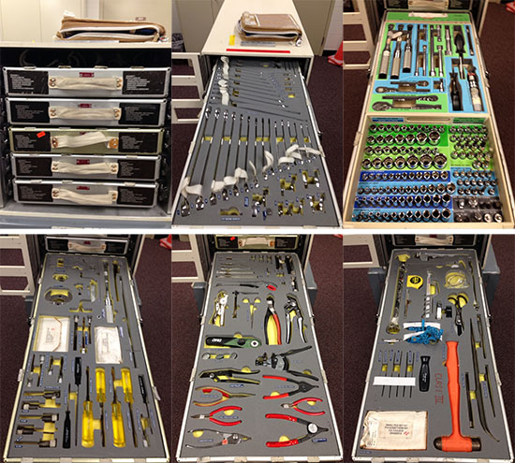

3/31/15

**Typical Spacewalk Activities**

-Most EVA space walks are not all that related unless they involve the same project in the last two years. However, I do notice that the spacewalks a lot of the time have to do with working on Ammonia tanks/pumps/tubes and working with cableage. Went through EVAs from 12-14

-Lubing?

- Installing materials for new construction eg. ports, latches,

-ISS is a constant construction zone- constantly adding

-<https://www.nasa.gov/audience/foreducators/spacesuits/home/challenges_spacewalking_index.html#.VRwIjcirxjY>

*Carr, Schwartz, Newman Article*

-”EVAs can be grossly characterized as planned, unplanned, or contingency (unexpected, but may be required for crew safety.”

-“Furthermore, the wearable computer system would function as an element for mission enhancement: not required for any EVA tasks, but used to support well-defined tasks at varying levels of complexity. It would serve to augment existing systems, not to replace them.”

“For components inside the suit, safety considerations include operation of electronics in a 100% oxygen atmosphere, out-gassing off-gassing issues, thermal restrictions, and the severe space constraints imposed by the close-fitting hard upper torso of the suit. Components outside the suit may have fewer environmental constraints, but must withstand the harsh environment of extreme temperatures and vacuum, and, to a much lesser degree, exposure to elemental oxygen, plasma, and micrometeoroids. Safety considerations will be addressed further in the technical requirements section.“

**Common Problems of Spacesui**t-

LOSS OF FINGERNAILS (OUCH!!!) (5 years old but interesting)

<http://www.popsci.com/science/article/2010-09/bulky-tight-fitting-gloves-cause-tough-nails-astronauts-lose-their-fingernails>

-Chafing, Rubbing, Feels raw around neck, shoulders, and hands

What needs to be monitored for spacesuit:

* Oxygen level
* Heart beat
* Suit pressure
* Blood pressure
* Solar radiation
* Body temperature
* [Suit temperature](http://www.universetoday.com/77070/how-cold-is-space/)